Workflow Name: Automated Company Research
Goal: Automatically conduct research about a company by entering just its name into Google Sheets using AI.
Result: Reduces error and manual data entry input.
Prerequisites
- OAuth ID setup in Google Cloud console.
- SerpAPI API keys
- OpenAI API keys
- Scraper API keys
- Airtable setup keys
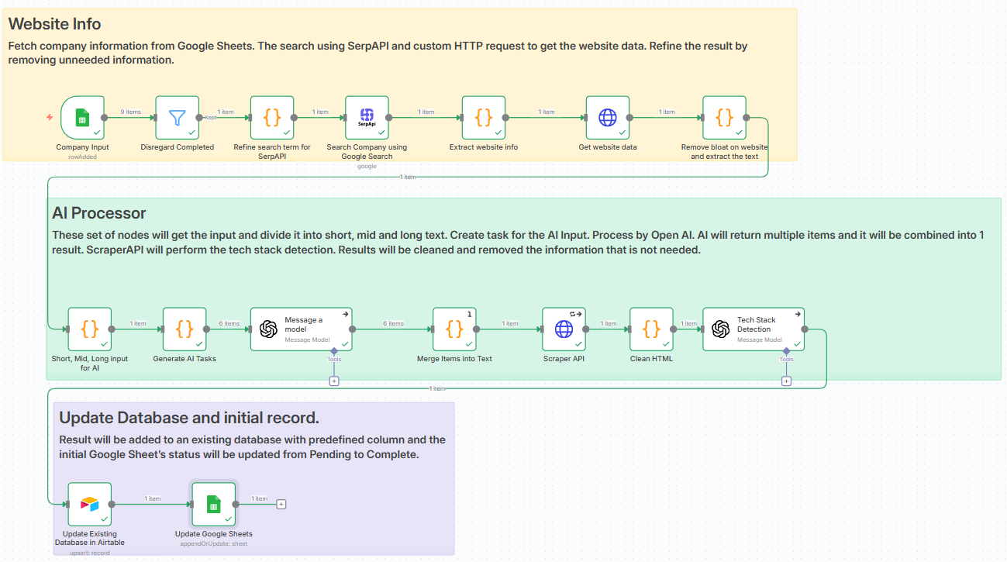
Node Name | Type | Description
Google Sheets | Trigger | Receives the input from the user.
Filter | Action | Filters input and output items that are only in Pending
Code | Logic | Handles cleaning, formatting, and extracting data from the input.
SerpAPI | Action | Google Search for specific company.
HTTP Request | Action | APIs that are not available in n8n. Used for getting additional website data like the HTML files and scraper.
OpenAI | Logic | Main AI processor for different tasks of company research.
Airtable | Action | This is where the output is saved.

Workflow Demo: https://www.loom.com/share/072c180cff544b09a7c7f8ebff5b250f

